# Introduction

In power electronics area, the converters and rectifiers are crucial for the motor drive system. In this project, the AC/DC converter is designed by APPE. In this simulation report, the possible topologies can be used are discussed and selection is made between them. Also, the selection criteria is explained. After the topology selection, the calculation and simulations are presented. The calculations contain both motor side and rectifier, converter side calculations. The simulations include both ideal and non-ideal cases. After, analysis of simulations and calculations, the components that are required, are chosen by using the result of these analysis. At the end of this report, the future plan of the design is explained by APPE.

# Problem Definition and Requirements

In this project, it is required to design a controlled rectifier for using to drive a DC Motor. As input, the adjustable AC source (variac) is used. This DC motor is connected to kettle which is used to boil to water. The DC motor is given in the Figure 1:

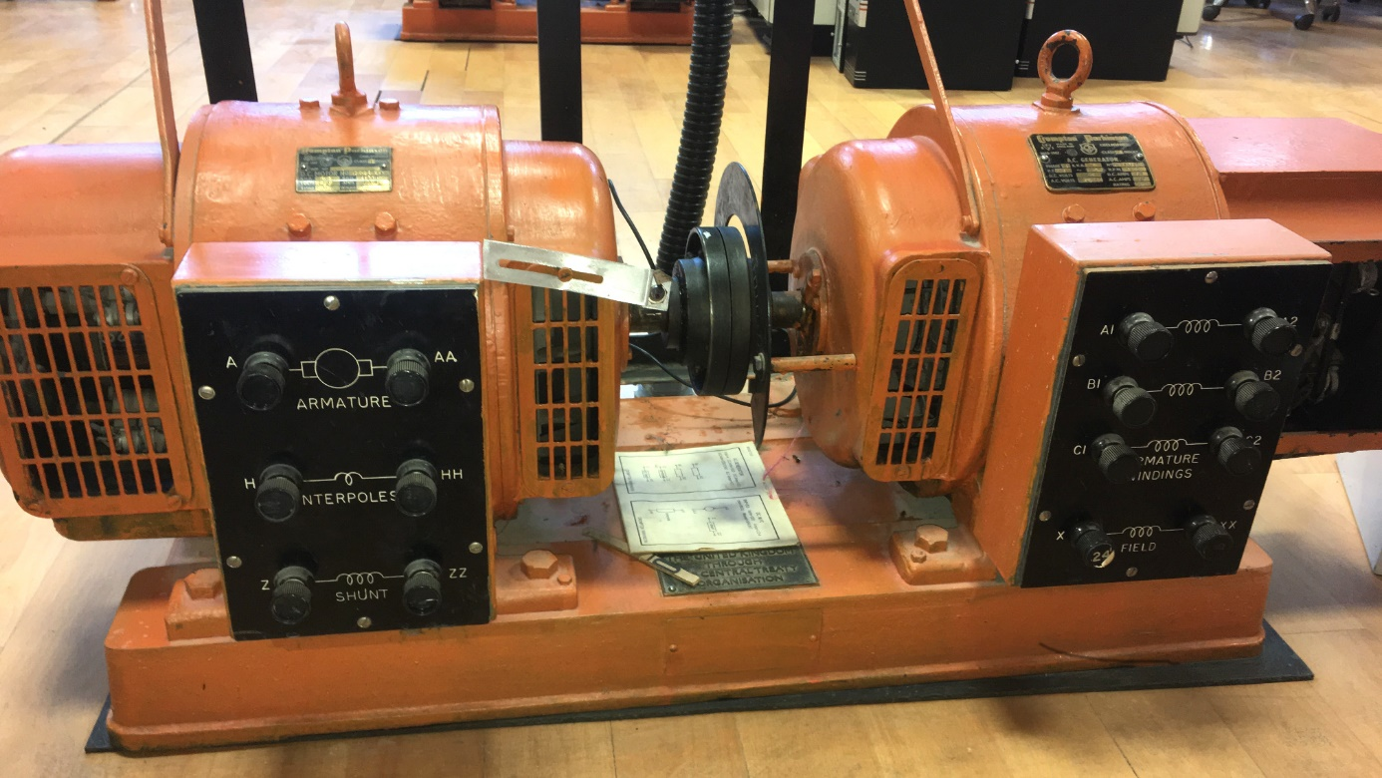

Figure : The DC Motor

The specifications of this motor as follows :

|  |  |
| --- | --- |
| Parameter |  |
| Armature Winding | 0.8 Ω, 12.5 mH |
| Shunt Winding | 210 Ω, 23 H |
| Interpoles Winding | 0.27 Ω, 12 mH |
| Mechanical Power | 5.5 HP |
| Rated Voltage | 220 Volts |
| Rated Current | 23.4 Amps |
| RPM | 1500 RPM |

Input and output requirements are as follows :

* Input : 3 phase or 1 phase AC Grid (Adjustable with variac)
* Output : Adjustable DC Output (Vmax <180 Vdc)

In next section,these following three possible topologies are discussed in terms of disadvantages and advantages :

* Three Phase Thyristor Rectifier
* Single Phase Thyristor Rectifier
* Diode Rectifier + Buck Converter